2/ 13/07

WEB PAGE DESIGN
Course Objectives: Students will utilize the skills and features they’ve learned in Dreamweaver to create the following website.
* You have been hired by the Bronx zoo to create an educational website for children.

Class Project
Root folder: Day Bronx Zoo

File name Document title Content
1. Index Home page - link names and images to pages.

2. Land Land animals - features 3 animals that live on land.

3. Air Air - borne animals - features 3 animals that fly.

4. Sea Sea creatures - features 3 animals that live in water.

Index – feature one image per animal in website.
Land – feature all 3 land animals.
Air – feature all 3 air-borne animals.
Sea – feature all 3 sea creatures.

EXAMPLE: Index

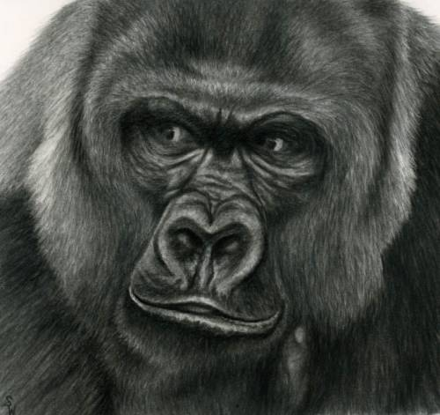
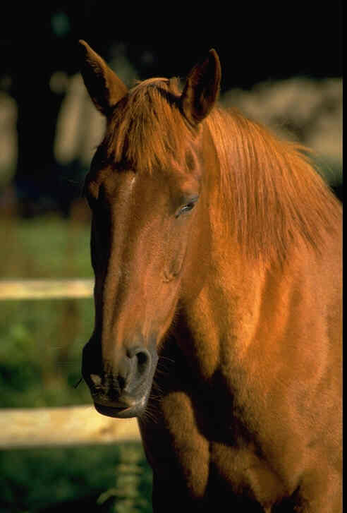
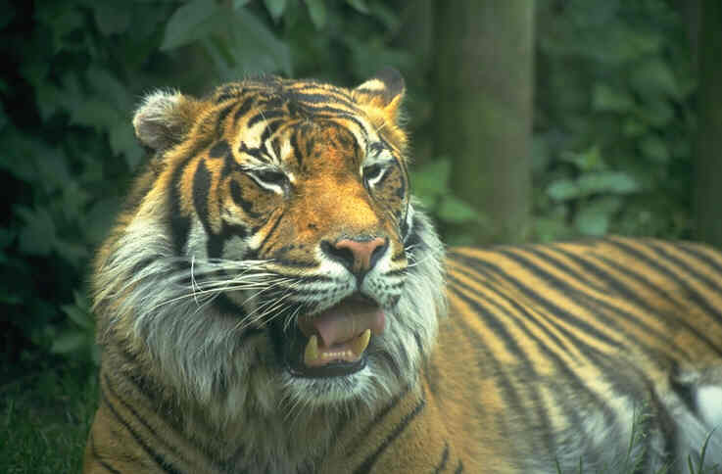
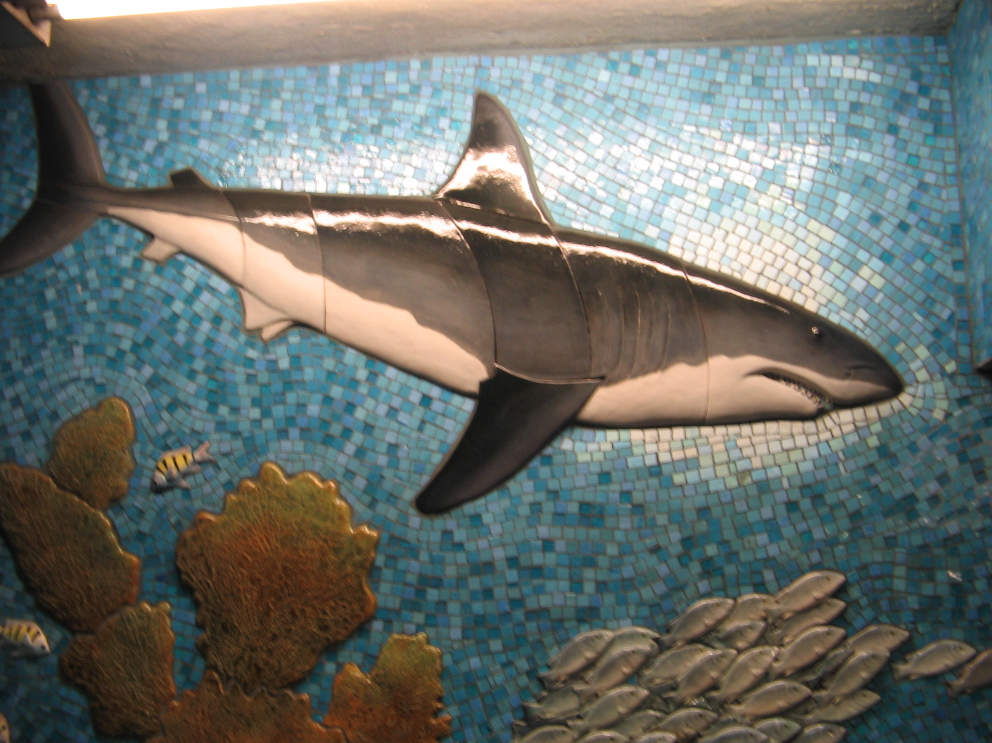
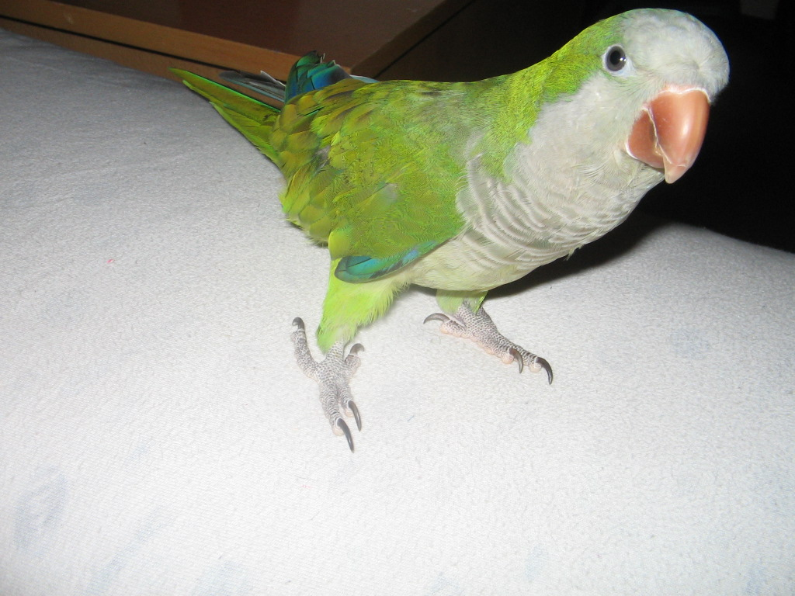
WEB PAGE: land animals

